**EXPERIMENT 5**

**Aim :**

Show and Analyse the Trace Format of NS2.

**Trace Files & Description :**

The file written by an application to store coverage information or overall network information in NS2, it is known as trace file. The **extension** for trace file is **.tr.** For all the programs written in NS2, a unique trace file is generated by user. The format of trace string consists of 12 fields which are shown below.

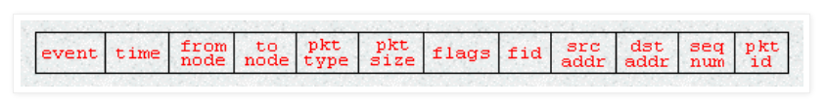

**Format of Trace File :**

**1. Event or Type Identifier –**

**+ :** packet enque event

**- :** packet deque event

**r :** packet reception event

**d :** packet drop event

**c :** packet collision at the MAC level

**2. Time –** at which the packet tracing string is created

**3. & 4. Source & Destination Node –** source and destination ID’s of tracing objects

**5. Packet Name –** name of the packet type

**6. Packet Size –** size of packet in bytes

**7. Flags –** 7 digit flag string

**“-” :** disable

**1st = “E” :** ECN (Explicit Congestion Notification) echo is enabled

**2nd = “P” :** priority in the IP header is enabled

**3rd :** not in use

**4th = “A” :** Congestion action

**5th = “E” :** Congestion has occurred

**6th = “F” :** TCP fast start is used

**7th = “N” :** Explicit Congestion Notification (ECN) is on

**8. Flow ID –** it shows the ID of packet

**9. & 10. Source & Destination Address –** the format of these two fields is **“a.b”** , where **“a”** is the address and **“b”** is the port

**11. Sequence Number –** it shows the sequence number

**12. Packet Unique ID –** the last field shows the unique ID of packet

**# Trace File Description :**

**s -** send packet

**r -** received packet

**d -** packet dropped

**f -** packet forwarded

**c -** collision of packet at MAC level

**t -** time at which packet tracing started

**Hs -** ID of hop

**Hd -** ID of next hop towards destination

**Ni -** Node ID

**Nx , Ny , Nz -** Coordinates of nodes situated

**Ne -** Node energy level

**Nl -** Trace level

**Nw -** Reason of the event

**AGT –** Agent

**RTR –** Routing

**END -** DROP End of Simulation

**COL -** DROP MAC Collision

**DUP -** DROP MAC Duplicate

**DERR -** DROP MAC Packet Error

**RET -** DROP MAC Retry Count Exceed

**STA -** DROP MAC Invalid State

**BSY -** DROP MAC Busy

**NRTE -** DROP RTR - NO ROUTE

**LOOP -** DROP RTR ROUTE LOOP

**TTL -** DROP RTR TTL has reached Zero

**TOUT -** DROP RTR - QTIME OUT Expired

**Is -** Source address of source port

**Id -** Destination address of destination port

**Il -** Packet Size

**If -** Flow ID

**Ii -** Unique ID

**Iv -** TTL value next hop into

**# MAC Layer Information :**

**Ma -** MAC Layer Duration

**Md -** Destination Ethernet Address

**Ms -** Source Ethernet Address

**Mt -** Ethernet Type

**# Packet Information :**

**-P arp -** Address Resolution Protocol

**-Po -** ARP Request / Reply

**Pm -** Source MAC Address

**Ps -** Source Address

**Pa -** Destination MAC Address

**Pd -** Destination Address

**Pn -** Nodes Trans versed

**Pq –** Flag

**Pi -** Route Request Sequence Number / Sequence Number

**Pp –** Flag

**Pl -** Reply Length

**Pe -** src of source routing

**Pw -** Error Report Flag

**Pc -** Report to whom

**Pb -** Link error from link a to link b

**-P cbr -** CBR data

**Pf –** how many level packet leave

**Po -** Optimal Number of Forward

**-P TCP -** TCP flow

**-Ps -** sequence number

**Pu –** acknowledgement

**Pf -** Packet Failure

**Screen Shots :**

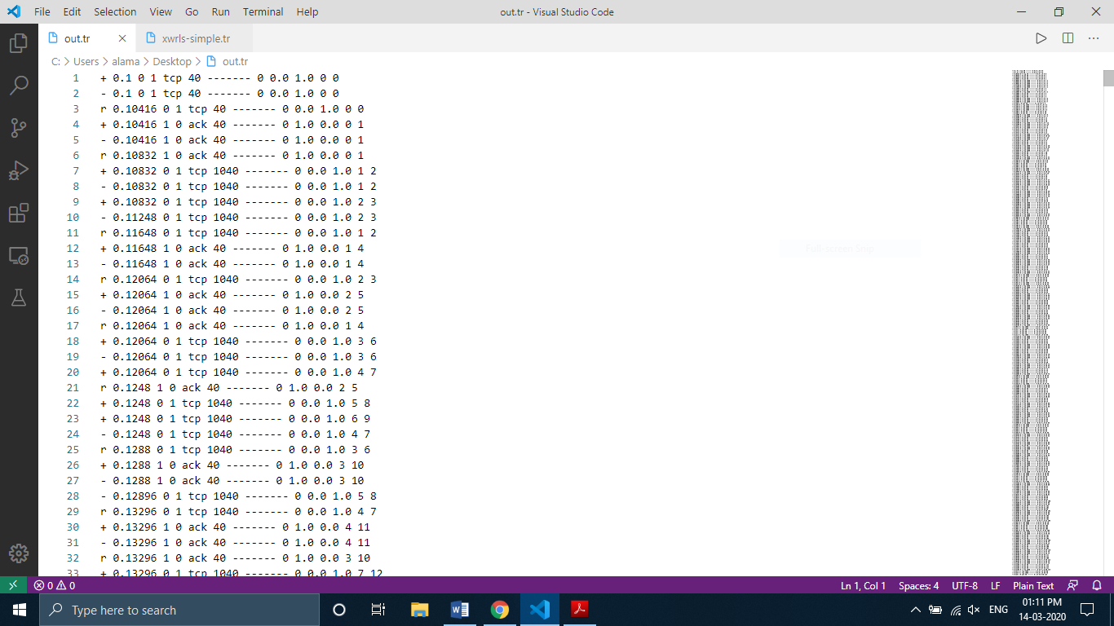

**Wired Network Trace File**

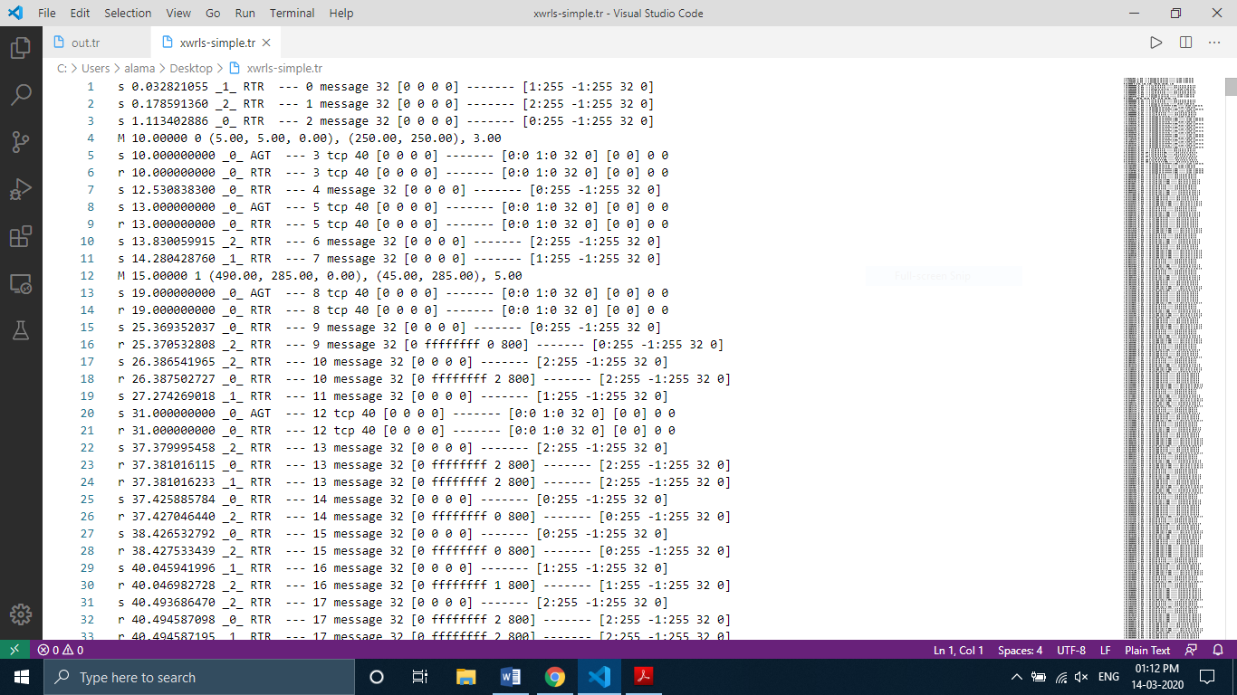

**Wireless Network Trace File**